DOCUMENT READING SYSTEM FOR BLIND PEOPLE (“READING EYE”)
19-20-J 17

E.M.D.D.Ekanayake
I.N. Kalansooriya
P.S.N. Kularathne
W.R.P. Fernando

Bachelor of Science (Hons) Degree in Information Technology

Department of Information Technology

Sri Lanka Institute of Information Technology
Sri Lanka

May 2020

DOCUMENT READING SYSTEM FOR BLIND PEOPLE (“READING EYE”)

19-20-J 17

E.M.D.D.Ekanayake
I.N. Kalansooriya
P.S.N. Kularathne
W.R.P. Fernando

Project Final Report
(Dissertation submitted in partial fulfillment of the requirements for the B.Sc. (Honors) degree in Information Technology Specialization in Information Technology)

Department of Information Technology

Sri Lanka Institute of Information Technology
Sri Lanka

May 2020
DECLARATION

I declare that this is my own work and this dissertation does not incorporate without acknowledgement any material previously submitted for a Degree or Diploma in any other University or institute of higher learning and to the best of my knowledge and belief it does not contain any material previously published or written by another person except where the acknowledgement is made in the text.

Also, I hereby grant to Sri Lanka Institute of Information Technology, the nonexclusive right to reproduce and distribute my dissertation, in whole or in part in print, electronic or other medium. I retain the right to use this content in whole or part in future works (such as articles or books).

Name | Student ID | Signature
E.M.D.D.Ekanayake | IT16102156
I.N. Kalansooriya | IT16176348
P.S.N. Kularathne | IT16165762
W.R.P. Fernando | IT16079328

The above candidates has carried out research for the bachelor’s degree Dissertation under my supervision.

Signature of the supervisor Date
(Ms. Suranjini De Silva)

Signature of the Co-supervisor Date
(Dr. Anuradha Jayakody)

ABSTRACT

Reading is an essential ability a person should have. Without reading you are pretty much futile. Because to complete day-to-day tasks you need to read at least once a day. From the email that were sent by your boss to a bill for something you purchased from store when you are heading home, you have to read. For the most part, we take it for granted. We do not think much about it because we have no problems with reading a bill with our own eyes. But for a blind user, the case is entirely different as it is not an easier task for them to read, even with Braille. Thus, this proposal proposed a Virtual Reading Assistant for blind and vision impaired people, which can be used to read text, images, charts, equations and table-based content in a document. The proposed mobile application will reduce the time to read a document efficiently. Particularly when comparing with a vision impaired person who usually read using Braille codes, it takes quite some time to read a document. According to several researches that were conducted regarding Braille reading speed, they concluded Braille was a slower method. Therefore, the proposed mobile application will reduce the reading time and make reading a pleasurable experience for the user. Moreover, the security of the application will be enhanced. In implementation process of this application, we will train different neural network models to detect and understand objects from the digital images of the document, which will be captured by the camera in the app. After analyzing the content of images, specific descriptions will be created using natural language processing techniques. Finally, we generate an audio file based on the previously created content description for the user to listen.

Keywords – Image Processing, Assistive Technology, Computer Vision, Deep Learning, Natural Language Processing, Artificial Intelligence

ACKNOWLEDGEMENT

First of all, we would like to thank Sri Lanka Institute of Information Technology (SLIIT) for providing the necessary resources to complete the research project successfully.
We extend our sincere gratitude to the Project Supervisors Ms. Suranjini de Silva for providing her invaluable guidance; feedback and time throughout the course of our research project for complete success.
Next, we would like to thank our co-supervisor Dr. Anuradha Jayakody, for his excessive support and guidance to achieve our project goals.
Also, we would like to thank the Project Coordinator Mr. Janaka Wijekoon, who provided the necessary information and deliver the lecture materials to complete the project successfully.
We would also like to thank all the members of the academic staff and those individuals who give their assistance and support.
Last but not least, we would like to thank our parents and family members for their support to make our project a success.
Finally, we would like to thank all the team members of the project for their contribution and effort towards achieving the project goals and objectives.

TABLE OF CONTENTS

DECLARATION | iii
ABSTRACT | iv
ACKNOWLEDGEMENT | v
TABLE OF CONTENTS | vi
LIST OF FIGURES | vii
LIST OF TABLES | viii
LIST OF DEFINITIONS, ACRONYMS AND ABBREVIATIONS | ix
1. INTRODUCTION | 1
- Background & Literature Survey | 1
1.2 Research Gap | 3
1.3 Research Problem | 4
1.4 Research Objectives | 5
2. METHADOLOGY | 6
2.1 System Overview | 6
2.2 Charts and Equations based Contents Reading and Detection (CEBCRD) | 7
2.2.1 Mathematical Equations based Content Identification (MEBCI) | 8
2.2.2 Chart based Content Identification (CBCI) | 8
2.3 Commercialization Aspects of the Product | 12
2.4 Testing and Implementation | 12
2.4.1 Testing | 12
2.4.3 Tools and Technologies | 22
3. RESULTS & DISCUSSION | 23
3.1 Results | 23
3.2 Research Findings | 27
3.3 Discussion | 27
3.4 Summary of Student Contribution | 28
4. CONCLUSION AND FUTURE WORKS | 29
5. REFERENCES | 30
6. APPENDICES | 32
Appendix A - Use Case Diagram of CEBCRD Component | 32
Appendix B – Use Case Scenarios of CEBCRD Component | 32
Appendix C - Class Diagram of CEBCRD Component | 35
Appendix D - Works Breakdown Structure (WBS) of Reading-Eye System | 36

LIST OF FIGURES

LIST OF TABLES

LIST OF DEFINITIONS, ACRONYMS AND ABBREVIATIONS

Table 1: Definition for the terms

Table 2: Glossary of Acronyms

1. INTRODUCTION

  - Background & Literature Survey

Assistive technology assists people with disabilities to achieve their ordinary life tasks and helps to improve their tasks in working, transportation, and majorly in academic activities at the same time, it guides them to accomplish better independence and makes the life more comfortable. According to the World Health Organization (WHO) official statistics, there are 285 million visually impaired people (partially or completely blind) in the world in which 39 million of them are blind and 87% of them are from developing countries [1]. At the same time, globally, it is estimated that approximately 1.3 billion people live with some form of vision impairment [2].
According to the major the development of the technology, there are some developed products to avoid the difficulties of the reding documents which help visually impaired people to improve their reading ability [3],[12].

However, focusing on the improvement of reading ability and gain knowledge for academic purposes for the visually impaired people there is a major impediment because they have limited resources for access to most of the specific types of documents.

Reading and detecting text-based contents and Region Identification

Due to the major development of modern technology, there are many existing document reading apps are available for visually impaired people.
Some of these are Amazon Kindle, BARD Mobile, Capti Voice, KNBF Reader, etc. [15]. Those accessible mobile apps are applications or specialized programs downloaded onto mobile devices for smartphones and tablets, that have accessibility built-in to compatible with screen reading or screen magnification software [19] that is built into or installed on the device for focusing visually impaired people [15],[16],[17],[18].

However, the market acceptance is less as useful details gathered from the developed apps are not remarkably more than that from the white cane and replies received from the tools are not many users friendly.
Therefore, the latest research efforts are being turned to come up with new Audio Assistance for Vision Impaired Individual to Recognize Graphical Content on Print Disable Documents called Schmoozer [11] which should reduce the impediments of previously mentioned applications.
Text, graphical images, equations, and tables are the main regions in print disable documents considered in the existing applications. The identification of the graphical regions identification done by the authors collected images of mathematical equations, text, tables and graphical images and stored them in separate folders. Then apply HOG feature extraction and Support Vector Machine (SVM) algorithm on the collected set of images to convert them into a trained data set [11]. Some of the applications have done pre-processing and OCR classification and detect the texts [34].

International Journal of Scientific & Engineering Research provided a solution for Text Detection and Recognition with Speech Output in Mobile Application for Assistance to Visually Challenged Person for using a camera-based assistive text reading system to read text labels and product packaging from hand-held objects. Text detection is to detect regions in an image that contain text characters. Methods of feature descriptor can broadly be classified as using a Histogram of the oriented

gradient (HOG) descriptor, Scale-invariant feature transform (SIFT), Speeded up robust features (SURF), Gradient location and oriented histogram (GLOH) algorithms [35].

Reading and detecting graphical Images-based contents and Table-based contents

As mentioned in the literature survey previously, some applications can identify and detect graphical images-based contents as below.

Schmoozer used to identify the graphical image-based contents separately and creates a text file with the meaning of the image. This process achieved by comparing the image with a trained database inside the server. The dataset in the database trained using the SVM algorithm. HOG feature extraction technique used to identify unique features in the image and convert into a decimal value to store in a database [11]. According to that the main purpose of the “Graphical image identification function” is separately recognizes and labels the images available in print disable document. Authors implemented a strong dataset, which contains a huge number of images of living beings and many single objects with significant behavioral changes. Then applied HOG feature extraction to identify unique features in the graphical image and convert into a decimal value to store in a database. The database was trained using SVM algorithm to convert the dataset into the trained dataset [11].

Moreover, Azati software indicates that the use of neural networks with deep learning is one of best the option to detect, analyze and read the graphical images because of the development of new technologies in the world [10]. Therefore, that is one of the optimal methods that we plan to implement our solution in this research.

Table based content identification function in Schmoozer is to recognize the type of data table (whether it is 2columns or 3columns) and convert table data into meaningful digitized text. It implemented with a strong dataset with a huge number of 2 column and 3 column tables are the foremost step in the table identification process. Then applied HOG feature extraction to identify unique features of 2 column and 3 column tables and convert into a decimal value to store in a database the database was trained using SVM algorithm method to convert the dataset into the trained dataset. When the function” obtain a cropped and identified table segment from graphical region identification function it extracts HOG features and converts into a decimal value. The decimal value was compared in with the trained data set to find the type of the table whether the table has 2 or 3 columns. The data inside the image of the table was read using in build the OCR function of MATLAB and wrote the data into a text file [11].

Reading and detecting charts-based contents and Equations based contents.

The Most software applications developed to detect and analyze text contents but most of them cannot detect chart-based content and equations-based content [15],[16],[17],[18].

Detecting equation regions from scanned books has received attention in the document image research community in the past few years. Compared with regular text blocks, equation regions have more complicated layouts so we cannot simply use text lines to model them. On the other hand, these regions consist of text symbols that can be reflowed, so that the OCR engines should parse them instead of rasterizing those like image regions.
A Simple Equation Region Detector for Printed Document Images in Tesseract is one of the researches that has been conducted for one of the equation detectors, which use to detect equations using Tesseract OCR engine. The equation detector is built into the layout analysis stage. Specifically, it works after the text line detection and before the paragraph/block partition, so that the detected regions won’t be mistakenly grouped into a text paragraph. In addition, we skip these regions during the recognition stage, because no special parser has been built yet in the Tesseract engine [14]. This will basically classify the text symbols then identify the text regions and expand the text regions to read and detect the equations-based contents.

Another research called Schmoozer mainly focuses to detect mathematical equations based on the separately recognize characters and symbols in a mathematical equation that are printed on documents and convert them into digitized text. The first step was designing of mathematical symbols and numbers using Photoshop in bitmap format. Bitmap files are easy to create and pixel data stored in a bitmap file could be accomplished by using a set of coordinates that allow the data to be conceptualized as a grid. Therefore, all the major mathematical characters were created in bitmap format and stored inside a folder called “letters_numbers”. Then created a MATLAB template and match each character /mathematical symbol/number into created bitmap images [11].

Moreover, according to the Schmoozer use to identify the equations by obtained input images from the graphical regions identification function Read image, Convert to grayscale and converted into a binary value and Finally match every character of the input image with the binary value obtained from the created template and regenerate the equation as digitized text. Function’s output is a set of single digitized values for a single character/symbol in the equation and converts to DDL file for use to web service [11].

When considering the literature survey for chart-based content detection, we were unable to find comparatively numerous researches since this feature compromise of new methodologies and techniques.

One of the major challenges in chart image classification is the variability of the structure and visual appearance of each chart type found from and conducted research called Convolutional Neural Network Based Chart Image Class [33].

However, the different approaches have been proposed in the literature to deal with the problem of chart image classification, the variation in chart style, size, color, resolution, and the content are not yet resolved.

Enhance the Security and Data Encryption

There are many of reading applications for visually impaired people in the app stores. but none of them has any encryption algorithm to secure their communications with servers. Therefore, we focused on another famous mobile applications that use encryption algorithm to secure the back-end communication. WhatsApp is a very famous communication app. It uses a protocol named ‘signal’ to encrypt data. This protocol uses asymmetric and symmetric key cryptographic algorithms [34]. Only one shared key use for encryption and decryption processes in symmetric key cryptographic algorithms.
However, in asymmetric key cryptographic algorithms, here are two keys to encrypt and decrypt named as public and private. When data encrypt with public key the encrypted data must be decrypted by using private key.

LastPass is an encrypted password manager. It can be used IOS, Android, windows and as an integrated browser extension for desktop [35]. Its use as a secure passwords' storage. All passwords will be encrypted with device-level AES-256-bit encryption with PBKDF2 SHA-256[36].and it also uses salted hashes to store passwords securely. AES algorithm with 256-bit long key is not very efficiency. But however, there is no back-end communication. Therefore, efficiency is not necessarily important fact. Viber is another famous communication app. It encrypts the message before sending it to anyone.it uses an ephemeral one-time 128-bit symmetric key for encryption [36] Salsa20 encryption algorithm being used for encryption [36] and it use Elliptic-Curve Diffie Hellman key-exchange algorithm for sharing the keys.

Signal is another famous app for the message encryption. It uses signal protocol for the encryption. The protocol based on the combination of the double Ratchet Algorithm, prekeys, and a Triple Diffie-Hellman (3XDH) handshake [37]. It uses HMAC-SHA256, Curve25519 and AES-256 as primitives [37].

WhatsApp, Viber and Telegram use end-to-end encryption because they are communication applications. WhatsApp encryption algorithm developed by a company named Open Whisper Systems. They developed an encryption algorithm using Perfect Forward Secrecy algorithm (PFS), the Double Ratchet Algorithm (DRA) and Off the Record algorithm (OTR). It is called Curve25519[34]. Also, WhatsApp use Elliptic-Curve Diffie Hellman key-exchange algorithm for sharing the keys. Telegram application as their own encryption algorithm called MTProto[3] which is developed using 256-bit AES.

  - Research Gap

The research gap could demonstrate why should we need to implement the proposed system and this will indicate what are the various drawbacks and needed improvements of the previously developed systems as a comparison with proved system and the previously developed systems by referencing the gathered information in the literature survey. This could show basically, how much the proposed system deviates from previously conducted researches.
As discussed in the literature review previously it seems that many visually impaired people also can improve their reading ability and, they can exposure to new areas by gain knowledge through listening to audio document reading systems.
However, after completion of the background and the literature survey, there were certain identified limitations that laid the foundation for our research. The proposed solution is based on to reduce those limitations and perform an improved better solution for visually impaired people and at the same allow the visually impaired people to reach the same level of reading level as a normally sighted person without a barrier by providing the descriptive idea and best understanding of texts, digital images, charts, tables and mathematical equations.

Most of the solutions the ones had been carried out in advance had a similarly faced when compared to the proposed system solution, furthermore developed features and integrated functionalities were minimal when compared with the proposed solution.

When reviewing the research gap, the technological advancements that have taken place over the restrictions and the limitations in the technologies at past times of development should not be disregarded, as the client-server data security and cloud storage advancements present as per today, did not exist back then.

The use of advanced machine learning techniques and image processing libraries, conventional neural networks, Deep Learning Frameworks and techniques, cloud hosting with data security are the sum of technologies that improve the usability and the widening factors which are the most trending technologies in the present that our proposed system wish to implement. With the use of new technologies, the result of the proposed system will become an accurate, more efficient, effective and optimal solution for the targeted assistive technology area for visually impaired people.

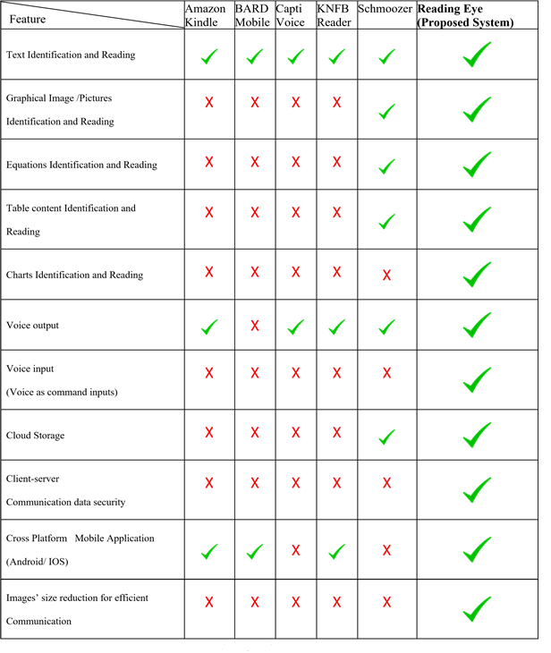
Table 3: Comparison of Reading Eye with existing systems.

  - Research Problem

Globally, Braille still is the primary reading method for blind people to access information and education independently. In this system, each character represented by a combination of one to six raised dots. A dot may be raised at any of the six positions to form 64 possible subsets. Without Braille codes, blind people would have never been able to read or write. Although it was and still is the best method, there are problems with the Braille system too.

For blind students, some subjects can be unattainable because textbooks and exams may not be readily available for those courses in a braille format. And for subjects like science, engineering, and mathematics, require advanced codes. These subjects are heavily contained with maps, charts, diagrams, figures and equations that have to be redesigned for the braille reading students to feel and understand a concept. It will be even harder for students who enrolled in biology classes. As there should be books which include images of human body, molecules, and cells, for students to refer. Because of the complexity of the contents in those subjects, it is hard to create the same book in braille format.

Not only the unavailability, but braille books are also usually more expensive than most college textbooks. It will cost up to $15,000 to convert just five chapters of a science book making it even harder to publish a science book in braille format because the conversion is difficult. Another issue with braille books is, they take up more physical space than normal printed books. A 1000-page math book could easily be 5000 pages in braille format. If a book is around this much larger, having thousands of pages, it will be difficult for a student to use the book.
As mentioned in the previous part, braille reading speed is relatively slower than the normal reading speed. Several kinds of research have been done regarding braille reading speed. And they concluded that braille is much slower. According to these facts and findings, it is obvious that there are some major issues with braille method. Since it was designed and introduced centuries ago, it may not be compatible with the needs and desires of a modern person.
Reading eye is based on machine learning algorithms. When image processing these algorithms need lot of process power. We strongly believe these issues can be solved with the help of modern technologies. Therefore, our research is going to be conducted to provide a solution for the above-mentioned problems.

  - Research Objectives

    - Main Objective

The main goal of the proposed system is to facilitate visually impaired people to read printed documents that are not written using the braille system and help them to improve their reading capability as normally sighted people.

    - Specific Objectives

2. METHADOLOGY

This section describes the techniques and mechanism which is used to implement the “Reading-Eye” application.

2.1 System Overview

According to the system overview of the proposed Reading-Eye application, it has the capability to auto capture a printed document and uploads it to a server automatically, and it provides better solution for detecting text, natural images, equations, charts and table-based contents in a document. Moreover, as the outcome, this application generates the audio of the detailed description of the identified content for the user to listen. Furthermore, the application is equipped with a secure data connection.

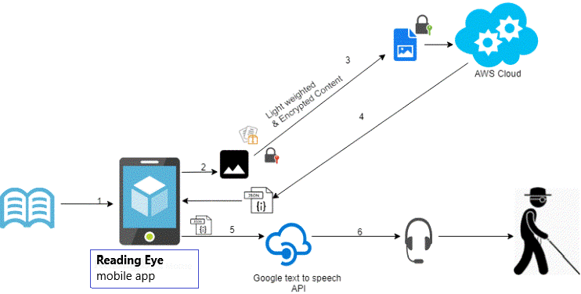

Figure 1: High Level Architecture Diagram of Reading - Eye System

2.2 Detecting printed document and auto capturing the image (DACI)

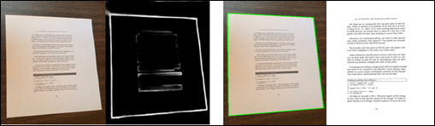
The developed mobile application (Reading-Eye) has the capability of auto capturing photos with the use of REA main interface. This module uses deep learning-based edge detection in OpenCV called as holistically nested edge detection (HED) for real time edge detection. HED make use of the side outputs of intermediate layers of images to generate final predictions. It is also capable of giving prediction of images with the help of convolutional neural network. The auto capturing images are stored in the phone mass storage.
Figure 3 : Sample output of the edge detection

Region detection and split upping (RDASU)

The main task is image segmentation. The segmentation is a process to separate meaningful individual objects from a captured digital image. There are many machine learning techniques to achieve this process. There were founded most of them are very slow and give low accurate outputs. Therefore, we decided to use computer vision, based image processing techniques with machine learning methods.
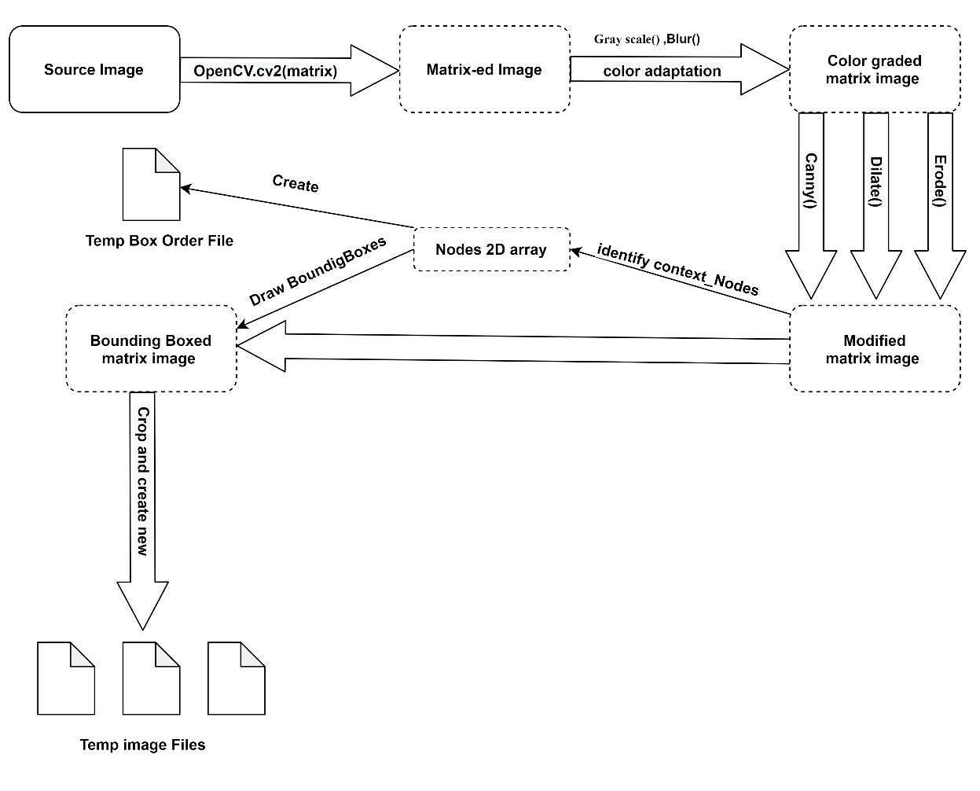
Firstly, load the image as OpenCV cv2 matrix. After that color adaptation to grayscale and Gaussian Blur, Canny, Dilate, Erode functioning. After identifying the context_Nodes. After that, stored nodes pass the 2D array and draw Bounding Boxes. After crop by bounding box outline and renaming save temp jpg file. Also, parallelly maintain an order of the bounding box node index and save to temp file.
Figure 4 : Region detection and split upping


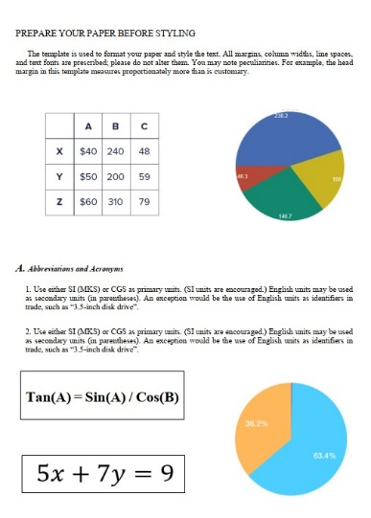
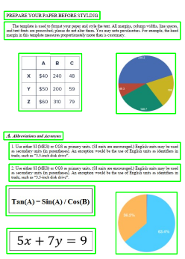

Figure 5 : Region detection output

2.2 Text based content identification (TBCI)

The main purpose of the text identification function is to identify and read the textual contents in printed documents. This was done using Tesseract OCR engine, which is the best OCR engine available. As the final output of the function, a JSON file will be generated using the read content. Then the content will be concatenated with output files from other graphical contents to make a final description of the original document image. The final description will be converted to an audio file for the user to listen by a Text-to-Speech API.

2.3 Graphical image-based content identification (GIBICI)

Image reading feature is used to generate a textual description about a natural image in a document the user is reading. The feature is expected to identify humans, different sorts of animals and objects and so on. When implementing this feature ImageNet weights were used to correctly identify those said objects in an image. It is an image database which contains thousands of images belonging to various categories. It contains about 1000 classes. Having so many classes in a single dataset is the reason for using ImageNet in this function. So that, it can identify more objects in the image accurately. The objective of this feature is to output a proper description about the image itself so that the visually impaired user can be aware of the contents of that image. After going through a big process, this feature is able to just do that.

As per technologies, both computer vision and natural language processing were used to read the image content and to create a language model to turn the understanding of the image into words in order to generate a textual description. The core of this module is training a deep learning model which is capable of predicting a suitable description for a natural image automatically. Therefore, the most important part is the model. This model consists of two sequential models. First model is image model and the second one is language model. Both do two separate tasks. But before training the model, there are some steps that need to be mentioned here. First one is preprocessing. It is the initial step of the entire training process.

In this feature, we used images and captions that describes the images as input. Prior to training, it is vital to preprocess these input data so that unnecessary elements could be removed and obtain an accurate final model. However, the processing step is different for both input types. For images, it is done not to remove unnecessary elements but to collect features in each image and combine them as a separate dataset. This step kind of speeds up the training.

- Preprocessing of Images

In this phase, we use a pre-trained feature extractor. Most used feature extractors InceptionV3, VGG16, VGG19, Mobile Net, Xception and so on. They each give various results. After trying few of them, we finally used InceptionV3 as it gave more accurate results and because it is a lighter model. This pre-trained model uses the ImageNet weights to extract features in an image. It is a convolutional neural network which consists of many layers.

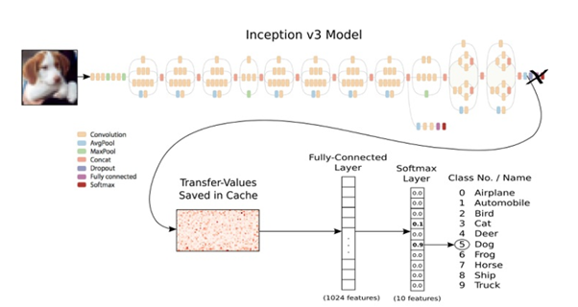
Figure 2: Classifying an object using the InceptionV3 [13].

Here is an example to show how to use InceptionV3 model to classify an object to its related class (in this case dog class). However, in our case we do not want to the classification. We use it to extract features in the images (e.g. animals, people) and use them as input to train our model. InceptionV3 contains many layers. Only the last layer gives us the output (classification). Since we do not want classification, we can remove the last layer of InceptionV3 and compile again, so that it outputs extracted features that we need. Output of newly compiled model is 1 X 1 X 2048 tensor vector. For the image reading component, we used Flickr8K dataset which consists of 6000 images and 30000 captions, each image having 5 captions. These captions describe the image. However, all the images in the dataset are processed using InceptionV3 and extracted features will be combined as one input array. Then it will be used as the input data in the image model we mentioned earlier.

- Preprocessing of Image Descriptions

Just like the images, preprocessing of image descriptions also a must to make the outcome more accurate. In Flickr8k dataset, one image has precisely 5 descriptions (single line though). These descriptions usually contain single letter words, punctuations, and even numbers. Therefore, we need to remove these unnecessary stuffs and clean the text. And we convert all the words to lowercase as well. After cleaning text, we can create a vocabulary out of all the words. Cleaning text helps to create a smaller vocabulary because of unnecessary words have already removed, which result in a smaller model that will train faster. Finally, we save dictionary of image identifiers and descriptions to a new file.

- Building the model

After the preprocessing, the next step is building the model. This model is the core of the entire program because it is this model that we use to predict descriptions about images later. This model consists of three parts.

- Photo Feature Extractor

This is a 48-layer InceptionV3 model trained on the ImageNet dataset. We have already extracted photo features using this pretrained model, so that we can use that features as input for this model. Feature vector expects input photo features to be a vector of 2048 elements. These input vectors are then processed by a Dense layer to create 128 element representation of the photo.

- Sequence Processor

This part consists of a word embedding layer for handling the text input and a Long Short-Term Memory (LSTM) recurrent neural network layer. RNNs were capable of connecting the previous information with the current task. But it had some shortcomings remembering all the relevant data and then connect that data with the current task. However, as a solution LSTMs came. LSTMs are a special kind of RNNs. These layers can remember information for a long period of time. It is extremely useful when generating descriptions. Because when generating a description, the machine has to find the most suitable word to generate after the previous word. Otherwise the sentence would not make any sense. LSTMs are extremely good at this task and that is reason for using an LSTM in our model too. This part expects input sequences with a pre-defined length. We used 34 words for that. Then the input sequences are fed into an Embedding layer which is followed by an LSTM layer with 128 memory units.

- Decoder

Both feature extractor (image model) and sequence processor (language model) are implemented as a Sequential model which output a 128 element vectors which will be used as the input in the decoder part to produce descriptions. When building the model, we did some experiments by changing certain layers at certain points to see how it will affect the output. After the merging of above two models, we used two Dense layers instead of LSTMs. However, the accuracy was not satisfying. Relatively LSTMs are much better as they do a better job at predicting the next word in a sentence. Therefore, when using two LSTMs, we got more accurate descriptions for the sampling image. That is the reason for using two LSTMs in the latter part of the model.

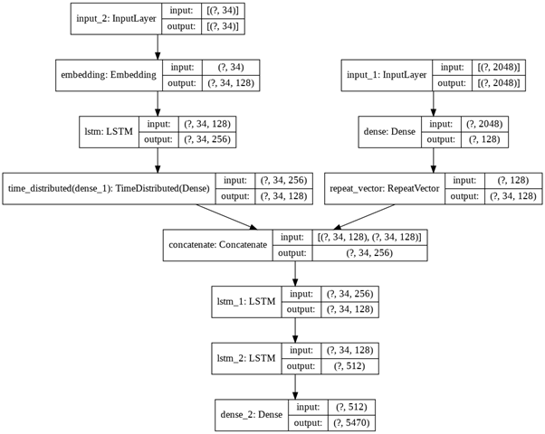

Figure 3: The structure of the trained model.

- Fitting of the model

As the final step, we need to compile and train the model with the dataset. The final model was trained using 300 epochs to increase accuracy and get a good final model. The more we train, the better results we get. However, because of some limitations with hardware, the model was trained using only about 2000 images. Because we needed a large amount of memory (RAM) to hold all the data, which we did not have. Therefore, only a subset of the entire dataset was used.

- Generating new descriptions

Though we have a trained model now, we cannot deploy it in a server with the same code to generate new descriptions. When using in a production environment, there is another mechanism. First, we load the model into our application. Then we should upload an image (search the directory for images in our case) to use with the image. Next, the image will be processed by a pretrained model and all the descriptions (saved earlier) will be loaded to the program. Finally, all inputs will be fed to our model and it will generate a suitable description for the given image.

2.4 Charts and Equations based Contents Reading and Detection (CEBCRD)

The CEBCRD is a component of the proposed Reading-Eye application. By analyzing the captured photograph of the document by the user system will encrypt the data and store it in the cloud storage. The captured image will separately divide into the relevant sub-modules as equations-based contents and chart-based contents etc. Moreover, after that stage graphical image of the equations-based contents and chart-based contents identified separately.

The identification of the chart-based contents is done by separating the chart size, type, color, resolution etc. Moreover, the equations also separate from the variables, operators, numbers, etc. After that initial process, separated identification of the charts and equations-based contents of the Reading-Eye system will generate detailed descriptive text content which contained the contents of the charts and equations. As the final output of the component, a JSON file is generated for the user to listen.

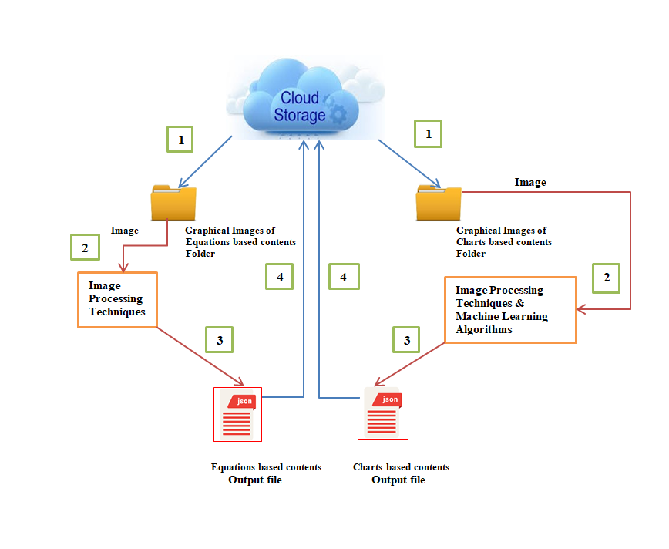

Figure 4: High Level Architecture Diagram of CEBCRD Component.

2.4.1 Mathematical Equations based Content Identification (MEBCI)

The main purpose of the Mathematical equations-based content identification function is to identify mathematical equations separately from the printed documents and recognize the numerical constants, characters and mathematical operators contained in the equation. Then the function will generate a description about the equation and save in a JSON file.
The first step of the function is identifying the mathematical equation using the JPEG file. This file format is used since it is a common image file format that digital cameras use to save their images. Furthermore, JPEG files apply the lossy compression method which helps to reduce the file size significantly without compromising the quality.

The Mathematical equations-based content identification function obtains input images from the graphical region identification function. The segmented image with equations will go through this function and will be preprocessed prior to the reading by Optical Character Recognition (OCR) tool.
The data inside the image of the equation is read using Tesseract OCR engine. After that, image will be converted to the grayscale using thresholding [15] for dimension reduction and model complexity reduction. Furthermore, image noise will be removed by applying the erosion and dilation (morphological operations) [16] using OpenCV library. After preprocessing, text of the preprocessed image will be read by the Tesseract engine.

Finally, mathematical equations-based content identification function will generate a description about the equation and saves it in a JSON file with separately identified numerical constants, characters and mathematical operators. Just like previous functions, output of this function will also be used to concatenate with other outputs to make the audio file later.

2.4.2 Chart based Content Identification (CBCI)

The Charts-based content identification function mainly focuses on identifying pie charts and bar charts from the obtained JPEG files which created by the graphical region identification function. As the final output of the function it will generate a description using the contents of both pie charts and bar charts.

Initially, the obtained JPEG image files will be preprocessed before proceeding to the main identification stage. The data inside image files will be read using in OCR engine. For the dimension reduction and model complexity reduction the read image will be converted to the grayscale using thresholding technique.
Furthermore, the morphological operators [16] of OpenCV such as, erosion and dilation will be applied to remove the noise of the image because result in pixel values that do not reflect the true intensities of the real scene with the noise of image.

Subsequently, the Charts – based content identification function proceeds two main identification stages as below.

- Pie Chart Identification

The significance of the function was based on the assumption that pie charts do not contain 3D effects, each wedge has a distinct color, and the corresponding labels are presented adjacent to the wedge.

As the first step the loaded prepossessed image file should use to detect the edges. The edge detection is performing through the Hough transform pattern recognition algorithm [17]. When detecting the edges of pie charts Hough transform pattern recognition algorithm use to detect circle positions and match their edges.

Given in a black circle on a white background, first we should guess its radius or a range of radiuses to construct a new circle. This circle is applied on each black pixel of the original picture and the coordinates of this circle are voting in an accumulator. From this geometrical construction, the original circle center position receives the highest score and most prominent circles.

Furthermore, by applying scikit-image open-source image processing library [18] which includes segmentation algorithms for geometric transformations, the image crop as the masked data and segmented. Moreover, founded segments count and segments values with the percentage of the pie chart will be identified through the SciPy package of key algorithms and functions [19] which act as the core to Python's scientific computing capabilities.

Finally, by creating the subplots and unpack the created array and generates a description of the chart. It contains the identified pie chart segments with the percentage values.

Figure 5: Pie Chart Segmentation and Percentages with Original Image

- Bar Chart Identification

The significance of the function was based on the assumption of bar chart orientation should be in the horizontal or vertical and we assume that bar charts do not contain any 3D effects. In addition, we assumed there are no texts inside the stacked bars and each stack has a distinct color.

As the first step the loaded prepossessed image file of the bar chart with correct orientation.
Otsu Binarization is applied for threshold [15] with using various filters to smooth the image. It is done by applying the Tesseract OCR and OpenCV image processing algorithms. After that the image will be inverted.

Figure 6: Otsu Binarization Applied Bar Chart Image for Thresholding

Perfectly prepossessed image file should confine our search space to the bars extracted from the connected component analysis. For that purpose, local search algorithm is used as follows. It will generate the X and Y scale dimension of the bars.

- As the beginning, the midpoint of the length of two edges of the rectangle should find along with its length. X-axis is used for the horizontally and Y-axis is used for vertically for the lengthwise in the bar chart.
- With the identification of start and end points we move along with the line made by them and detect sudden changes in the pixel values between the two adjacent points. The border or the adjacent point that separates two adjacent stacks is taken as the center of the pixel points.
- The process should continue until the finding the all the stacks inside all the bars.

Hough transform pattern recognition algorithm [17] and box detection algorithm [20] are used to detect rectangular bars separately in the bar chart. The process of applying the above algorithms and detecting the bar chart from the prepossessed image as follows.

- Defining two kernels as to detect horizontal lines and vertical lines. It will define rectangular kernel with the length based on the width of the preprocessed image.
- After defining the kernels, morphological operations of the image processing are applied for detect horizontal and vertical lines.
- Getting rid of grid lines accurately to detect the bars and then no noise will occur for false bar extraction.
- Adding waiting parameters as alpha = 0.5 and beta = 1- 0.5. Then it will make the quantity of an image to be added to make new image and this function helps to add two images with specific weight parameter to get a third image as summation of two image.

Figure 7: Horizontal and Vertical Lines Detected, Weighted Parameters Applied Image

As the next step, contours for image, this will detect all the bars and sort them from top to bottom by sorting counters using Python and OpenCV.

Following figure 6 depicts the bounding box as a yellow color line in the identified bar chart.

Figure 8: Bounding Box Identified Final Bar Chart Image.

Furthermore, loop over all the counters to find the all the boxes and crop the part which has a rectangle and save those into a new folder. The folder contains the exact detected bars of images.

Finally, generates a description using the identified bounding boxes of the bar chart. It contains the identified bar charts with maximum and minimum scaled values of the X and Y axes. The description will be merged with outputs of other function as necessarily to generate the final audio file.

2.5 Table based content identification (TBCI)

Table data reading feature is used to read contents of the table images. This feature is able to read tables with any number of columns without adhering to 2 or 3 column types. The only constraint is that the table should have horizontal and vertical lines. The technique used here relies on identifying the table structure, so that it must have both vertical lines and horizontal lines. Hence, it does not work on tables with no lines.
Since this component also is required reading text from an image, we used the Tesseract OCR tool to extract characters from the image. When working with OCR, as the first step we need to do the preprocessing. Initially before reading the text, the image must read, converted into grayscale, do thresholding and inverting. The purpose of gray scaling is to provide less information for each pixel mostly because grayscale images are enough for many tasks so there is no need to use more complicated and harder-to-process color images. Automatic thresholding is used to extract useful information encoded into pixels while minimizing background noise.
Detection of boxes in the image is the next step. For that task Morphological operations (erode, reconstruct, dilate are examples for morphological operations) are used. By using OpenCV library morphological operations can be done on the image. Here we define two rectangular kernels with the length based on the width of the image. First kernel is to detect horizontal lines and second kernel to detect vertical lines. After defining kernels, we do morphological operations (erode operation) to detect the vertical and horizontal lines in the table. After detecting lines, they should be saved as separate images like below.


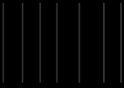

Figure 9: Vertical line structure. Figure 10: Horizontal line structure.

As the next step both horizontal and vertical images should be added together and create the final image with entire table structure without unnecessary lines or text. The final image will only contain boxes excluding text in the original table image. This way we can eliminate noise from the image and identify boxes with information precisely.
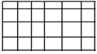

Figure 11: The final structure of the table.

After getting the structure of the table we must find contours in the image. For that we use findContours() method in OpenCV. It finds all the boxes in the image. Then we can sort the boxes from top to bottom. Now loop over all the contours, find the location of all the boxes and crop the part which has a rectangle and save it into the folder. By cropping the box, we can ensure the text inside the box will be read accurately and in order because when reading the table directly by OCR engine it reads the words horizontally regardless of word order (especially in columns). If we directly read images using OCR, there is no way to differentiate columns from rows as all information are read as text line by line. By using this method, not only we can separate columns and rows we can use them to generate meaningful descriptions at the same time. Then the column cells (cropped cells) and row cells should be read iteratively using OpenCV and read the text in the cells using Tesseract OCR engine.
As the final step, we can generate a meaningful textual description using columns values and row values of the table and generate an audio file using Text-to-Speech API for the generated textual description for the user to listen.

2.6 Securing the client-server connection (SCSC)

2.6.1 Security and light weighting

This section contains methodologies about how to secure client and server side, how to light weight the image and how to secure cloud using cloud policy.
After taking the picture it will be resized and split into image segments and then image segments will be encrypted using AES hybrid encryption algorithm with a 256-bit key and send to the cloud as an image stream (Figure 12).

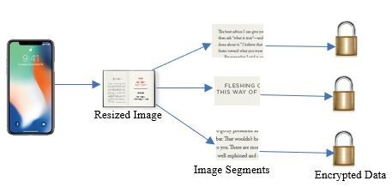

Figure 12: Client Side

The cloud will receive the encrypted segments and it will decrypt them and merge them together to get the full image. The key for the encryption will exchange using Diffie–Hellman key exchange method.
Server and client have common two numbers p and g and a secret number. client generate a key using p, g and secret number and then send to the server. Server generate a key using its secret number and p and g and then send to the client. After that server create a secret key using client’s key and server’s secret number. Client creates secret key using its secret number and server’s key. Both secret keys are same. This is called Diffie–Hellman key exchange method. This method is used to exchange key through insecure channels. In this method the key is not sending through insecure channels.
After taking the picture the mobile application creates a connection to the server. And then it will generate a key and send it to the server. The server will do the same. Then both parties create same secret keys. Then the app will resize and split the image into segments. Then the segments will be encrypted using secret key and send to the server.

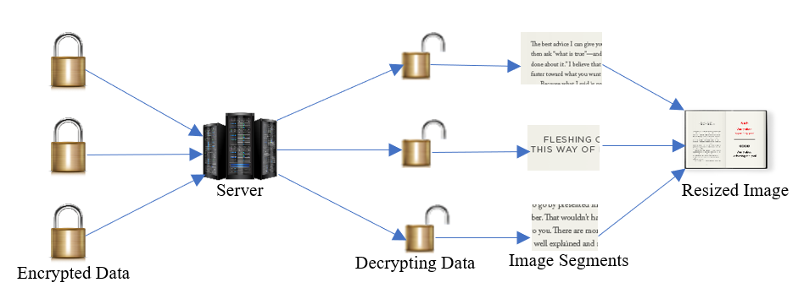
Figure 13: Server Side

2.6.2 Securing client and server communication
Due to advancement of modern technology cyber-attacks to IT systems are rapidly growing in a considerable rate. Hackers can intercept client-server communications very easily. Therefore, need an encryption mechanism to secure data from hackers. The encryption is converting readable and understandable data to unreadable and meaning less data. When hackers intercept encrypted data, they cannot read or understand it. This way we can secure data and secure client server connection.
They are many encryption algorithms. Not every encryption algorithm is secure. Hackers can crack some encryption algorithms. According to NIST (National Institute of Standards and Technology) encryption algorithms must possess vital two functions if they are secure.
- Diffusion
- Confusion

Diffusion is concealing the relationship between the plain text and the ciphertext.
Confusion is obscuring the relationship between the key and the ciphertext.
When considering the key length of the encryption algorithm, encryptions have higher chance to cracked if they have keys which are having short key length. Hackers can use brute forcing method to crack these encryptions.
Therefore, I had to choose an algorithm which has confusion and diffusion, and which has longer key length. Therefore, I choose most famous known to be secure AES algorithm. U.S.A use this algorithm to secure their data.

AES is originally invented by Vincent Rijmen and Joan Daemen. It is a symmetric block cipher. It encrypts data block by block. It can have 256-bit length key. It is known as a successor cipher of famous DES cipher.
When implementing AES on android we must consider about the device’s performance. Because AES need more process power. AES has four main functions.

2.3 Commercialization Aspects of the Product

The “Reading-Eye” application is mainly focusing on the vison impaired community. Moreover, it is mainly targeted for the vision impaired students who are willing to read the complex document contents like mathematical equations, charts, tables, natural images and text-based contents through an audio.

The application is developed through the high security in cloud platform and our main goal is to reduce the impediments of the reading capability of complex documents contents for vision impaired readers. Moreover, to make their reading capability and improve their knowledge through reading as a normal sighted people.

2.4 Testing and Implementation

2.4.1 Testing

This section of the document will be discussing about the testing phases carried out to validate the integrity of the work done to check whether the actual results match the expected results and to ensure that the software system is defect free and also to involves execution of a software component or system component to evaluate one or more properties of interest.
Moreover, to identify errors, gaps or missing requirements in contrary to the actual requirements.

As per the ongoing standard procedures, testing was carried out in five different phases which are discussed below.

- Unit Testing

Unit testing is a type of software testing where individual units or components of software are tested. The purpose is to validate that each unit of the software code performs as expected. In Reading-Eye application basically region identification, text based content identification, chart based content identification, mathematical equations based content identification, images based content identification and table based content identification test as unit wise in the initial stage.

- Module Testing

Module testing is used to check whether the individual modules are work properly. In Reading-Eye application we checked the charts and equations based content identification module, tables and image identification module, region and text identification module and security module separately in the module testing.

- Integration Testing

Upon the completion of unit and module testing, the modules are to be integrated which gives raise to integration testing. Therefore, applying the integration testing to the Reading-Eye system that verifies the functional, performance, and reliability between the modules that are integrated.

- System Testing

System Testing is a level of software testing where complete and integrated software is tested. The purpose of this test is to evaluate the system's compliance with the specified requirements. Before the application is launch to the end user system testing is applied to the Reading-Eye system.

- User Acceptance Testing

This was the phase where the system went through testing done by the end user, which gave feedback on the status on whether the expectations are fulfilled.

2.4.2 Implementation

The implementation of the Reading-eye system Charts and Equations based Contents Reading and Detection (CEBCRD) done by applying the machine learning and image processing techniques. The voice output which use as the final output for the end user was generated though the implementation of a REST API.

- Implementation of Mathematical Equations based Content Identification (MEBCI)

2.4.3 Tools and Technologies

- Tesseract OCR

Tesseract is an optical character recognition engine with open-source code, this is the most popular and qualitative OCR-library. It is free software, released under the Apache License. OCR uses artificial intelligence for text search and its recognition on images.

Tesseract is finding templates in pixels, letters, words and sentences. It uses two-step approach that calls adaptive recognition. It requires one data stage for character recognition, then the second stage to fulfil any letters, it wasn’t insured in, by letters that can match the word or sentence context.


- OpenCV

OpenCV (Open Source Computer Vision) is a library of programming functions mainly aimed at real-time computer vision. Most commonly used for Image Processing. It is mainly used to do all the operation related to Images. The library is cross-platform and free for use under the open-source BSD license.


- Postman

Postman is a popular API client that makes it easy for developers to create, share, test and document APIs. This is done by allowing users to create and save simple and complex HTTP/s requests, as well as read their responses. The result - more efficient and less tedious work.

3. RESULTS & DISCUSSION
3.1 Results

In this section, allocates to discuss about all the results obtained from the implemented features of the CEBCRD component and accuracy of them.

- Accuracy of Mathematical Equations based Content Identification (MEBCI)

50 input images were tested to calculate the average accuracy of the mathematical equations-based content identification function..

▪ Expected output = 1
▪ Total number of operators and operands include in the equation = n
▪ Weighted value for one operator or operand (Wn) = 1/n
▪ Number of accurate operators and operands in the actual output = An
▪ Accuracy of the digitization process (Ac) = Wn x An
▪ Maximum accuracy (Am) = 100 x execution number
Average accuracy (Aa) = [(Σ Ac) / Am] x100

Average accuracy (Aa) Equations Identification = [1200 / (12x100)] x 100%
= 100%

Below table contains the samples of tested experiment images with the calculation of the accuracy of the function.

Table 4: Accuracy of Mathematical Equation Based Content Identification

Sample output result of Mathematical Equations based Content Identification (MEBCI) represents as follows.

Figure 18: Sample Result of MEBCI

- Accuracy of Chart based Content Identification (CBCI)

Charts -based content identification function results were generated using 40 samples of input images data as 20 pie charts and 20 bar charts. The compound function of chart detection including pie charts detection and bar chart detection shows it average accuracy as 92.5%.

Calculation is based as follows.

Average
Accuracy = [Correct occurrences of input data sample / Total input data sample] x100%
(Aa)

Aa Pie charts = [18/20] x 100% = 90%
Aa Bar chart = [19/20] x 100% = 95%
Average accuracy (Aa) chart Identification =[ (90+95) / 2] x 100% = 92.5%

Sample output result of pie chart identification and bar chart identification is display as follows.

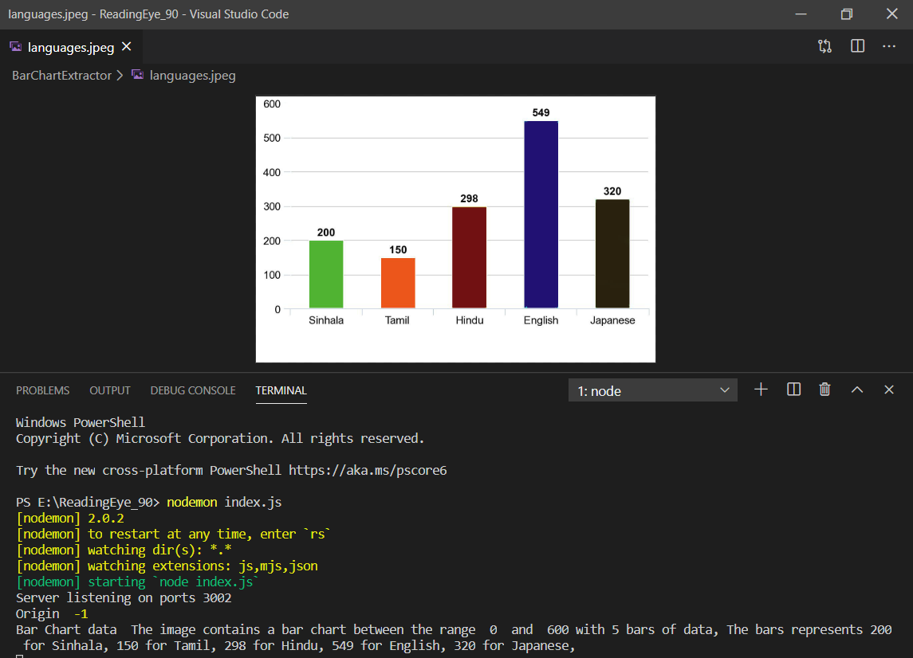

Figure 19: Sample Result of Bar Chart Identification

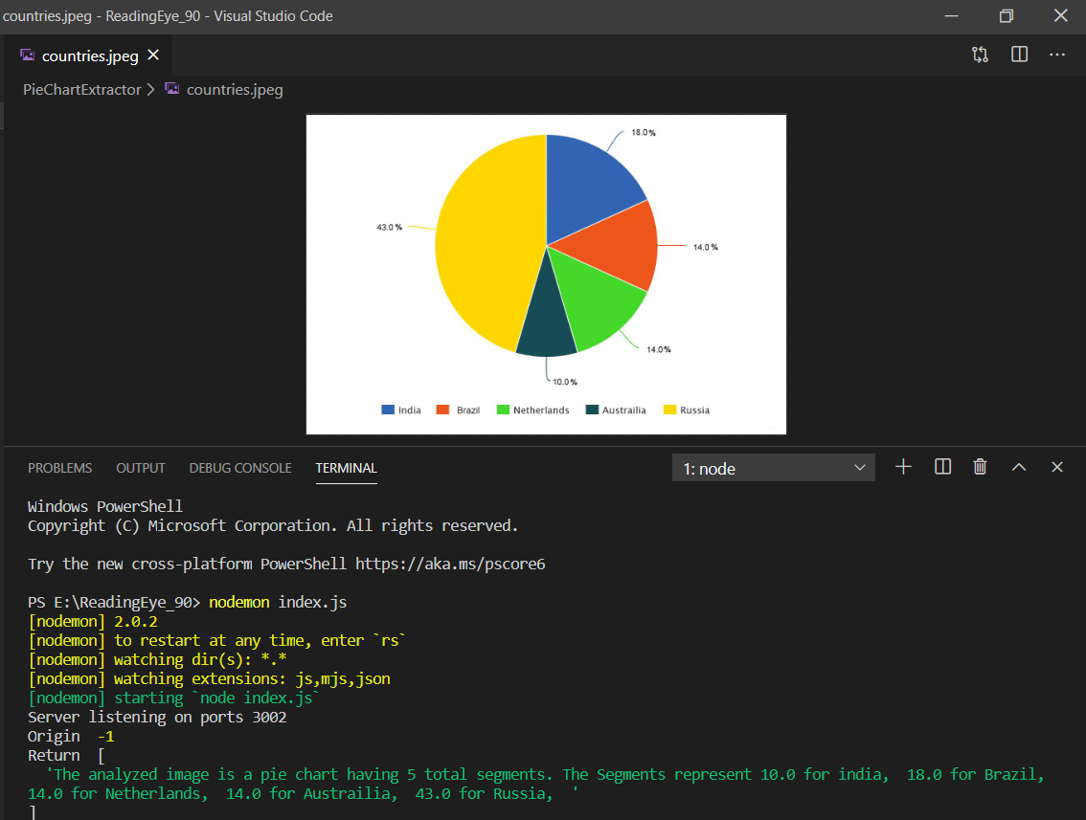

Figure 20: Sample Result of Pie Chart Identification
- API Requests Sending Sample Results

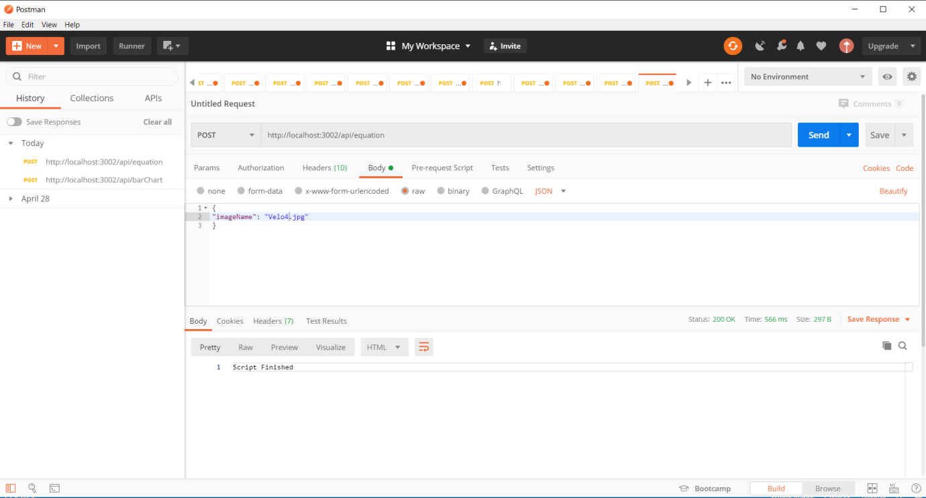

Figure 21: API Request to Get the Sample Result of MEBCI

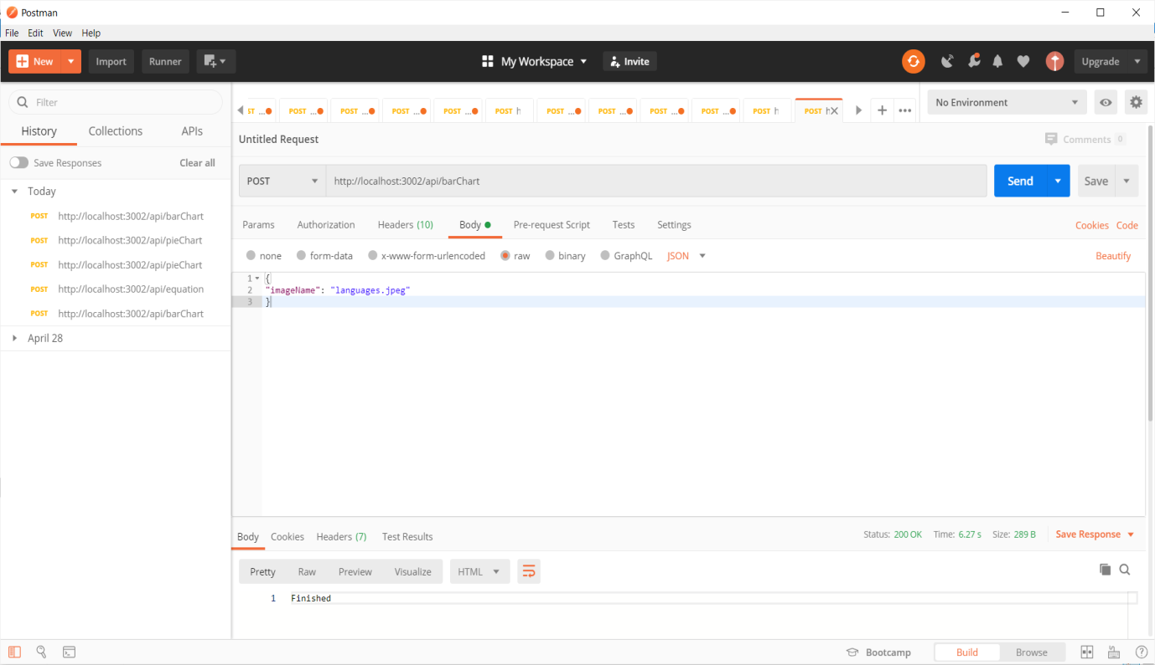

Figure 22: API Request to Get the Sample Result of Bar Chart

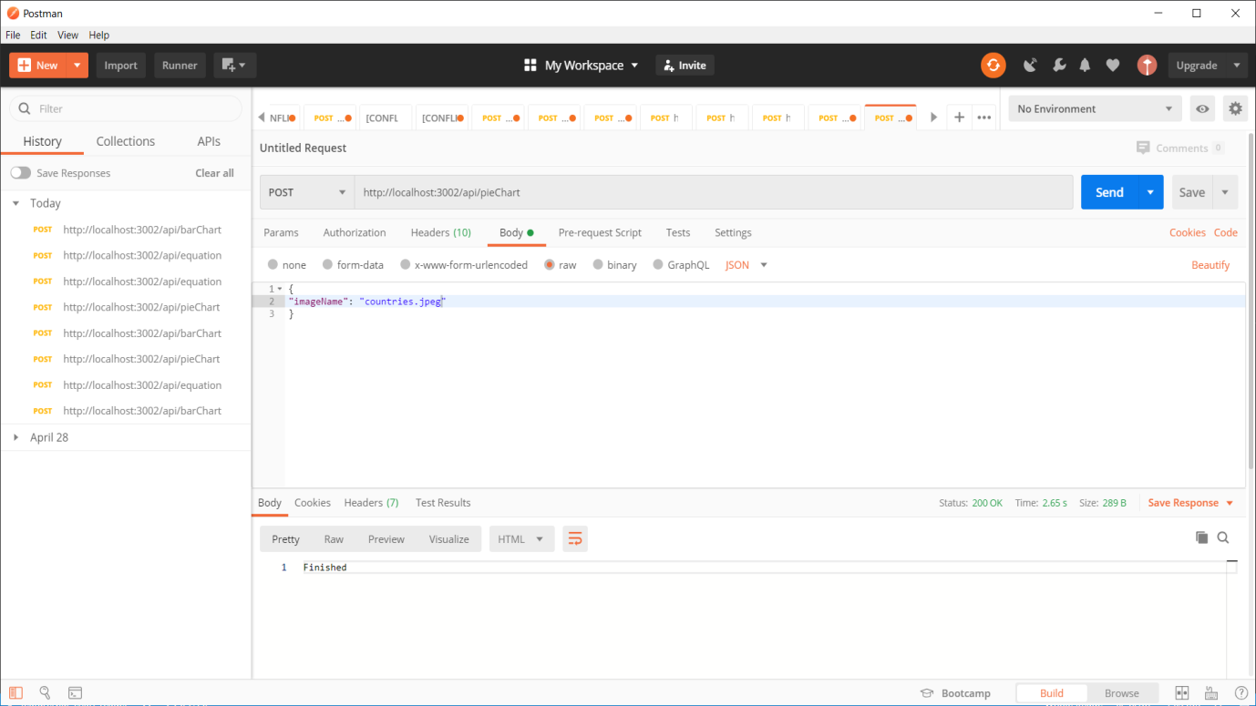

Figure 23: API Request to Get the Sample Result of Pie Chart

3.2 Research Findings

According to the previous researches on this domain, there is no any other developed system to identify all chart based contents, Image based contents, Mathematical equations based contents, Tables based contents and Text based contents with descriptive audio generation. Moreover, there were unable to find any similar mobile application with previously mentioned identifications.

The most significant findings of the research project were all the developed main functions worked with more than 90% of accuracy level. Therefore, It can be clearly seen that the final developed Reading-Eye system application is perform well and it will be major benefit for visually impaired users to get the knowledge of reading complex documents by the use of this solution in future.

3.3 Discussion

3.4 Summary of Student Contribution

Table 5: Summary of Student Contribution

Student ID | Student Name | Work Allocation
IT16165762 | P.S.N.Kularathne  Analyzing and Describing Charts and the Mathematical Equations based contents in the Documents | - Identify the charts, mathematical equations in the uploaded digital photos of the document.  - In charts - Identify the type of the charts as,  - Bar charts  - Pie charts etc.  - Represent the relevant data of the charts accordingly by using machine learning and image processing techniques.  - In equations - Identify numbers, variables, and mathematical operators in,  - Linear equations  - Basic trigonometric equations  Accordingly using image processing techniques.  - Create a detailed description of the identified content of charts and equations.  - Generate an audio file of that detailed description for the user to listening purpose by implementing REST API service.

4. CONCLUSION AND FUTURE WORKS

In this research, we proposed a solution that is capable of reading images, charts, equations and tables in a printed document using image processing, deep learning and natural language processing. The process consists of region detection and separation, secure encryption and decryption of the original document images, region analysis and content reading, conversion to textual description of the read content and lastly conversion the description to the audio narration. The system was developed mainly to help visually impaired persons to read documents easily and without someone else’s support. As a further benefit, it limits the need to use Braille formatted books as it can read many types of graphical contents in a document. With all these features, Reading Eye will provide better solution for visually impaired people to gain to read the document contents of information and fulfill their knowledge in better way.
As for future works, we propose the following suggestions mentioned below,
- Implement a feature to read tables that are having no horizontal and vertical border lines.
- Extend the chart reading function to read other chart types such as line charts, area charts and scatter plots.
- Include a feature to the existing system that can analyze graphs.
- Develop an iOS application to attract more users.

5. REFERENCES

[1] Who.int. (2018). GLOBAL DATA ON VISUAL IMPAIRMENTS 2010. [online] Available at: https://www.who.int/blindness/GLOBALDATAFINALforweb.pdf [Accessed: 06-Aug-2019].

[2]World Health Organization, 15-Jan-2019. [Online]. Available: https://www.who.int/blindness/en/. [Accessed: 06-Aug-2019].

[3]"Assistive technology", En.wikipedia.org. [Online]. Available: https://en.wikipedia.org/wiki/Assistive_technology#Visual_impairments. [Accessed: 16- Aug- 2019]

[4]A. Hellem, “Resources for the Visually Impaired,” All About Vision. [Online]. Available: https://www.allaboutvision.com/lowvision/resources.htm [Accessed: 06-Aug-2019].

[5]"Canny edge detector", En.wikipedia.org, 2019. [Online]. Available: https://en.wikipedia.org/wiki/Canny_edge_detector [Accessed: 20- Aug- 2019].

[6] N. Gamage, K. Jayadewa, S. Senanayake, K. Udeshitha and A. Jayakody, "Audio Assistance for Vision Impaired Individual To Recognize Graphical Content on Print Disable Documents", Annual conference 2017 - IET - Sri Lanka, 2017. [Online].Available: http://theiet.lk/wp-content/uploads/2017/10/24-p9.pdf.%20%5bAccessed:%2023-%20Aug-%202019%5d

[7]"A Simple Equation Region Detector for Printed Document Images in Tesseract - IEEE Conference Publication", Ieeexplore.ieee.org, 2019. [Online]. Available: https://ieeexplore.ieee.org/iel7/6627713/6628563/06628621.pdf [Accessed: 22- Aug- 2019].

[8]"Accessible Mobile Apps | American Foundation for the Blind", Afb.org, 2019. [Online]. Available: https://www.afb.org/blindness-and-low-vision/using-technology/assistive-technology-products/mobile-apps [Accessed: 20- Aug- 2019].

[9]"An In-depth Evaluation of the BARD Mobile App from the National Library Service for the Blind and Physically Handicapped | AccessWorld | American Foundation for the Blind", Afb.org. [Online]. Available: https://www.afb.org/aw/15/2/15607 [Accessed: 20- Aug- 2019].

[10] Play.google.com. [Online]. Available: https://play.google.com/store. [Accessed: 21- Aug- 2019].

[11] "Read text aloud. PDF reading books speak text to voice, read it out loud", Captivoice.com.15 [Online]. Available: https://www.captivoice.com/capti-site/public/entry/explore. [Accessed: 22- Aug- 2019].

[12] J. Amara, P. Kaur, M. Owonibi and B. Bouaziz, "Convolutional Neural Network Based Chart ImageClassification.."Pdfs.semanticscholar.org, 2019. [Online].Available:https://pdfs.semanticscholar.org/5fe7/c360e851f648095bb630eec742c7b809cf2b.pdf. [Accessed: 23- Aug- 2019].

[13]"A Simple Equation Region Detector for Printed Document Images in Tesseract - IEEE ConferencePublication",Ieeexplore.ieee.org,2019.[Online].Available:https://ieeexplore.ieee.org/iel7/6627713/6628563/06628621.pdf. [Accessed: 02- Sep- 2019].

[14] J. Amara, P. Kaur, M. Owonibi and B. Bouaziz, "Convolutional Neural Network Based Chart ImageClassification." Pdfs.semanticscholar.org,2019.[Online].Available:https://pdfs.semanticscholar.org/5fe7/c360e851f648095bb630eec742c7b809cf2b.pdf. [Accessed: 23- Aug- 2019].

[15] Nelli, F. (2017). OpenCV & Python - The Otsu's Binarization for thresholding. [online] Meccanismo Complesso. Available at: https://www.meccanismocomplesso.org/en/opencv-python-the-otsus-binarization-for-thresholding/ [Accessed 1 Mar. 2020].

[16] "Morphological Image Processing", Cs.auckland.ac.nz, 2020. [Online]. Available: https://www.cs.auckland.ac.nz/courses/compsci773s1c/lectures/ImageProcessing-html/topic4.htm. [Accessed: 13- Jan- 2020].

[17] Scikit-image.org. (n.d.). Circular and Elliptical Hough Transforms — skimage v0.12.2 docs. [online] Available at: https://scikit image.org/docs/0.12.x/auto_examples/edges/plot_circular_elliptical_hough_transform.html#algorithm-overview [Accessed 2 Feb. 2020]

[18] Scikit-image.org. (n.d.). Circular and Elliptical Hough Transforms — skimage v0.12.2 docs. [online] Available at: https://scikit-image.org/docs/0.12.x/auto_examples/edges/plot_circular_elliptical_hough_transform.html [Accessed 2 Feb. 2020].

[19] Scikit-learn.org. (n.d.). scikit-learn: machine learning in Python — scikit-learn 0.22.2 documentation. [online] Available at: https://scikit-learn.org/stable/ [Accessed 3 Feb. 2020].

[20] Medium. (n.d.). A Box detection algorithm for any image containing boxes.. [online] Available at: https://medium.com/coinmonks/a-box-detection-algorithm-for-any-image-containing-boxes-756c15d7ed26 [Accessed 4 Feb. 2019].

6. APPENDICES

Appendix A - Use Case Diagram of Reading-Eye System

Figure 24: Use Case Diagram of Reading-Eye System

Appendix B - Usecase Scenarios of Reading-Eye System

Appendix C - Class Diagram of Reading-Eye System

Figure 25: Class Diagram of Reading-Eye System

Appendix D - Works Breakdown Structure (WBS) of Reading-Eye System

Figure 26: Work Breakdown Structure Diagram

